P E S COLLEGE OF ENGINEERING MANDYA 571401



**VISVESVARAYA TECHNOLOGICAL UNIVERSITY**

**Jnana Sangama, Belagavi**

A Report on

Skill Development Internship

# “ENTERTAINMENT FRONTEND WEBSITE”

Submitted as a part of Skill Development Internship Points required in partial fulfillment for the award of the

##### BACHELOR OF ENGINEERING DEGREE

**Submitted by**

#### Shushruth Gowda MB [USN: 4PS22CI048]

**Under the Mentor ship of Dr. Umesh D R**

**HOD & Professor, Dept. of AI&ML, PESCE Mandya.**

**P. E. S. COLLEGE OF ENGINEERING, MANDYA - 571 401.**

**Department of Computer Science and Engineering(AIML).**

**2023-2024**

# P.E.S. COLLEGE OF ENGINEERING

MANDYA-571401

**(An Autonomous Institution Affiliated to VTU, Belgaum)**

### DEPARTMENT OF COMPUTER SCIENCE AND ENGINEERING(AIML)

**CERTIFICATE**

This is to certify that, **Shushruth Gowda MB[USN: 4PS22CI048] ,** a bonafide students of PESCE, have successfully completed the Skill Development Internship Point Program entitled “Entertainment Frontend Website” required in partial fulfillment for the award of the degree of **Bachelor of Engineering in Computer Science and Engineering (AIML)** of **P.E.S. College of Engineering, Mandya, VTU Belgaum** during the year **2023-2024**. It is certified that all corrections/suggestions indicated in internal assessment have been incorporated in the report deposited in the library. The internship project has been approved as it satisfies the academic requirements in respect of **Internship-1 (P22INT408)** prescribed for the degree in **Bachelor of Engineering**.

Signature of the mentor Signature of HOD

**Dr Umesh D.R Dr Umesh D.R**

HOD & professor, Dept. of CSE(AI&ML) HOD & professor, Dept. of CSE(AI&ML)

PESCE, Mandya PESCE, Mandya

I , **Shushruth Gowda MB [USN: 4PS22CI048],** students of 4th semester B.E, Department of Computer Science and Engineering (AIML), P.E.S. College of Engineering, Mandya, declare that the Skill Development Internship Point Program entitled “Entertainment Frontend Website” has been completed and the report for the same is submitted as a part of AICTE Activity Points required in partial fulfillment for the award of the BACHELOR OF ENGINEERING degree in the Department of Computer Science and Engineering (AIML) by the Visvesvaraya Technological University, Belgaum during the year 2023-2024.

I also declare that to the best of my knowledge, all the information in the report is true and collected from individuals as listed, and I take sole responsibility for any information mismatch or mistakes in the report.

Place: Mandya Date: 22-07-2024

The satisfaction that accompanies the successful completion of any task would be incomplete without the mention of the people who made it possible and under whose constant guidance and encouragement the task was completed. This intership project, "**Entertainment Frontend Website**" has been a significant milestone in my academic journey, and I would like to take this opportunity to express my gratitude to all those who have contributed to its successful completion.

First and foremost, I consider it my cardinal duty to express the deepest sense of gratitude to the Activity Coordinators and my mentor, **Dr. Umesh D.R** ,Professor and Head of the Department of Computer Science and Engineering (AI&ML), PESCE Mandya. His invaluable guidance, encouragement, and support have been instrumental in every stage of this project. His insightful feedback and constant motivation have helped shape this project into its final form. I am deeply indebted to him for his expertise, which he generously shared, and for his unwavering support throughout this journey.

I would also like to express my sincere gratitude to **Dr. H M Nanjundaswamy**, PESCE Mandya, for his timely help and inspiration during the tenure of the course. His advice and guidance have been pivotal in overcoming various challenges encountered during the project. His constant encouragement has been a source of strength, enabling me to push the boundaries of my capabilities.

Finally, I extend my heartfelt thanks to all the faculty members of the Department of Computer Science and Engineering (AI&ML), PESCE Mandya. Their dedication to teaching and mentorship has provided a strong foundation of knowledge and skills necessary for the completion of this project. Their support and encouragement have been crucial in navigating through various academic and technical aspects of the project.

This project focuses on developing a frontend website for entertainment purposes. The website consists of multiple HTML pages, each tailored to different aspects of entertainment such as sports, movies, and premium content, with a user-friendly login page to access personalized features. By organizing the website into distinct sections, users can effortlessly explore various entertainment domains and enjoy a customized browsing experience.

The development process involves using HTML for structuring the content, CSS for styling and layout, and JavaScript for adding interactivity and dynamic behavior to the website. HTML provides a solid foundation for the website's content, ensuring that it is well- organized and accessible. CSS enhances the visual appeal and layout, creating a cohesive and aesthetically pleasing design that aligns with modern web standards. JavaScript introduces dynamic functionalities that enrich the user experience, making the website more engaging and interactive.

The main goal is to provide a seamless and engaging user experience for visitors, allowing them to easily navigate through different sections of the website and access the content they are interested in. This includes intuitive navigation menus, responsive design elements that adapt to various screen sizes, and interactive features that respond to user inputs. The website aims to be both visually appealing and user-friendly, ensuring that visitors can find and enjoy the content they seek with minimal effort.

In summary, this project represents a significant effort in building a sophisticated frontend website dedicated to entertainment. It demonstrates the effective use of modern web technologies to create an engaging, user-centric platform that caters to diverse entertainment preferences. The successful implementation of this project serves as a testament to the potential of frontend development in enhancing user engagement and satisfaction in digital experiences.

## Introduction:

The "Entertainment Frontend Website" project is designed to create a comprehensive platform that caters to a wide range of entertainment interests. The primary focus of this project is on developing a user-friendly frontend website that provides easy access to various forms of entertainment, including sports updates, movie information, and exclusive premium content. Each section of the website is tailored to meet the specific needs of users, ensuring that they can quickly find and enjoy the content they are looking for.

The user interface of the website has been meticulously crafted to ensure a visually appealing and intuitive design. Key sections such as sports, movies, and premium content are prominently featured, allowing visitors to navigate effortlessly between different categories. The homepage serves as a central hub, showcasing the latest and most relevant content while providing users with easy access to the various sections of the website. The thoughtful layout and design prioritize user experience, making it simple for visitors to explore the content that interests them.

The overarching goal of this project is to deliver a seamless and engaging user experience that keeps visitors coming back for more. By integrating essential web technologies, the website aims to provide an interactive and dynamic environment where users can enjoy entertainment content without any hindrances. This project not only highlights the importance of well-structured web design but also emphasizes the need for functionality that enhances user engagement. In doing so, the "Entertainment Frontend Website" sets out to become a go-to destination for entertainment enthusiasts, fostering a vibrant online community where users can easily access and enjoy their favorite content.

The development of the "Entertainment Frontend Website" involved a carefully selected array of technologies that work together to create a seamless and engaging user experience. Below is a detailed overview of the primary technologies employed in the project:

* **HTML (HyperText Markup Language):** HTML is the backbone of the website, providing the essential structure for all content. Each page of the website— such as the homepage, sports page, movies page, premium content page, and login page—was meticulously crafted using HTML. This markup language allows for the organization of various elements, including text, images, and links, ensuring that information is logically arranged and easily accessible for users. The use of semantic HTML tags enhances the website's readability
* **CSS (Cascading Style Sheets):** CSS was employed extensively for styling and layout purposes. By defining the aesthetic aspects of the website, CSS enhances its visual appeal and ensures a cohesive design across all pages. Key features such as color schemes, typography, spacing, and responsive design were implemented using CSS, allowing the website to adapt seamlessly to different screen sizes and devices. The use of CSS classes and IDs facilitates consistent styling, contributing to a polished and professional look that attracts users and encourages prolonged engagement with the site.
* **JavaScript:** JavaScript played a crucial role in adding interactivity and dynamic behavior to the website. The incorporation of JavaScript functionalities enriched the user experience by providing features such as automatic sliders for showcasing featured content, search functionality for users to query movies, and form validation for the login page. These interactive elements not only enhance user engagement but also contribute to the website's overall functionality. JavaScript allows for real-time updates and interactions without requiring page reloads, creating a smoother and more enjoyable browsing experience for users.

#### Carousel Slider Creation:

The website incorporates a visually appealing carousel slider that showcases featured content dynamically. This feature allows users to view a rotating selection of highlights, such as top movies or latest sports events, enhancing the overall visual experience. The carousel is designed to capture users' attention and encourage exploration of various content types.

#### Video Playback on Hover:

To provide an interactive experience, the website implements a video playback feature that activates upon hovering over movie thumbnails. This allows users to preview trailers or clips without needing to click through to another page, streamlining the browsing process and making it easier for users to decide on content they wish to explore further.

#### Scrollable Movie Lists:

The website features scrollable lists of movies that allow users to browse through extensive collections effortlessly. This functionality is particularly useful for displaying categories such as "Latest Releases" or "Top Picks," enabling users to navigate through a variety of options without feeling overwhelmed. The scrollable design promotes user engagement and encourages visitors to discover new content.

#### Automatic Slide Transition:

To enhance user experience, the carousel slider includes automatic slide transitions. This feature ensures that content is continuously refreshed and highlighted, keeping users engaged as they navigate through the website. The automatic transitions can be customized to allow users to pause or manually control the slider, providing flexibility and control over their browsing experience.

### DAY 1

On Day 1, I began by setting up the foundational project structure for the "Entertainment Frontend Website." This initial phase was crucial for organizing the entire development process efficiently. I created the core HTML files necessary for the website, including the homepage (index.html), sports page (sports.html), movies page (movies.html), premium page (premium.html), and login page (login.html) as shown in fig 1.1. Each HTML file was meticulously crafted to serve its specific purpose within the website, ensuring a clear and intuitive navigation flow for users.

In addition to the HTML files, I also created corresponding CSS files for each page. The CSS files were designed to maintain a consistent aesthetic across the website, adhering to a unified visual theme. I organized the files into a logical directory hierarchy. This included creating separate folders for HTML, CSS, and JavaScript files, along with subdirectories for images, fonts, and other assets. This organization facilitated easier management and scalability of the project, allowing for smooth integration of additional features and content in later stages.

Furthermore, I set up a local development environment to test and preview the website as I progressed as shown in fig 1.2. This involved configuring a local server and ensuring that all dependencies and tools required for development were properly installed. By doing so, I was able to quickly identify and resolve any issues, ensuring that the website would function as intended across different devices and browsers.

Overall, Day 1 laid a solid foundation for the "Entertainment Frontend Website," setting the stage for subsequent development tasks. By establishing a well-organized project structure, creating essential HTML and CSS files, and setting up a version control system, I ensured that the development process would be efficient, scalable, and maintainable.

##### Creating HTML and corresponding CSS, JavaScript files for each page.

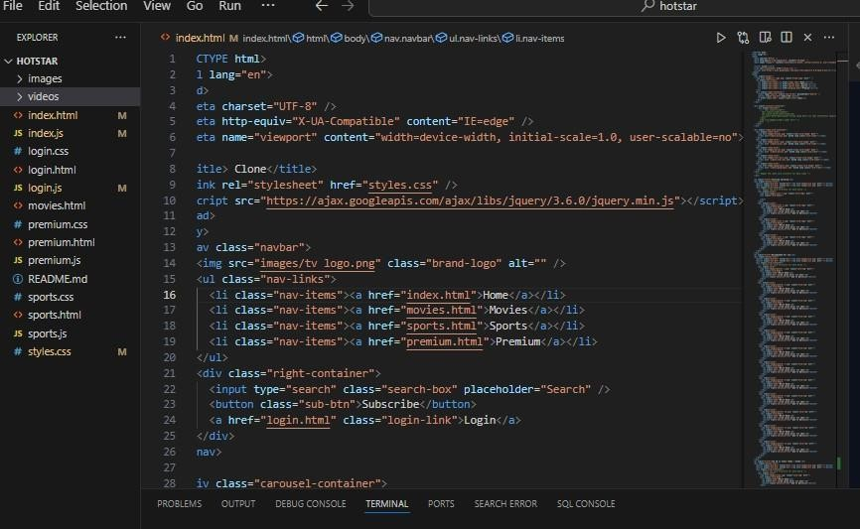

Fig 1.1

##### Set up a local development environment to test and preview the website

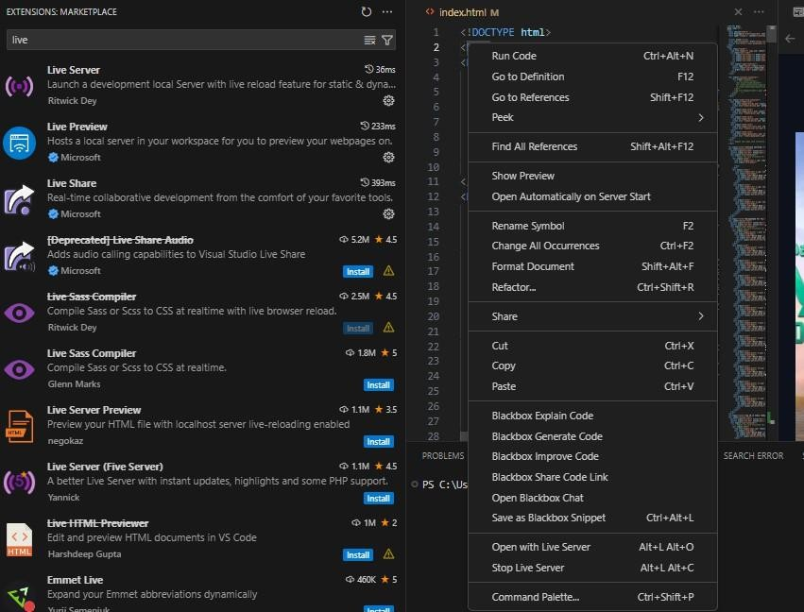

Fig 1.2

On Day 2, I focused on designing the layout and structure of the homepage (index.html). The goal was to create an engaging and user-friendly interface that would serve as the entry point to the entertainment website. I began by using HTML to create various sections for featured content, navigation menus as shown in fig 2.1, and a footer. Each section was meticulously planned to ensure that the most important information was easily accessible to users.

To enhance the visual appeal, I applied CSS to style these sections. This involved choosing a color scheme that was both attractive and cohesive, designing a layout that was both functional and aesthetically pleasing, and ensuring that the design was responsive across different devices. Special attention was given to typography, spacing, and alignment to create a professional and polished look.

In addition to static design elements, I implemented basic JavaScript functionalities to enhance user interaction and engagement. This included:

**Carousel for Featured Content:** A dynamic carousel was added to showcase the most popular and recent content as shown in fig 2.2. Users can navigate through the carousel to view different highlights, which adds an interactive element to the homepage.

**Sliders:** Various sliders were incorporated to display trending topics, new releases, and other featured sections. These sliders make it easy for users to browse through a large amount of content quickly.

**Video Cards:** Interactive video cards were created to provide a preview of the latest videos as shown in fig 2.3. Each card includes a thumbnail, title, and brief description. When hovered over or clicked, the video cards offer more details or a quick play option, enhancing the multimedia experience.

**Index.html (home page) buttons to navigate to different html page**



**Home page containing sliders**

**Video Cards**

Fig 2.1

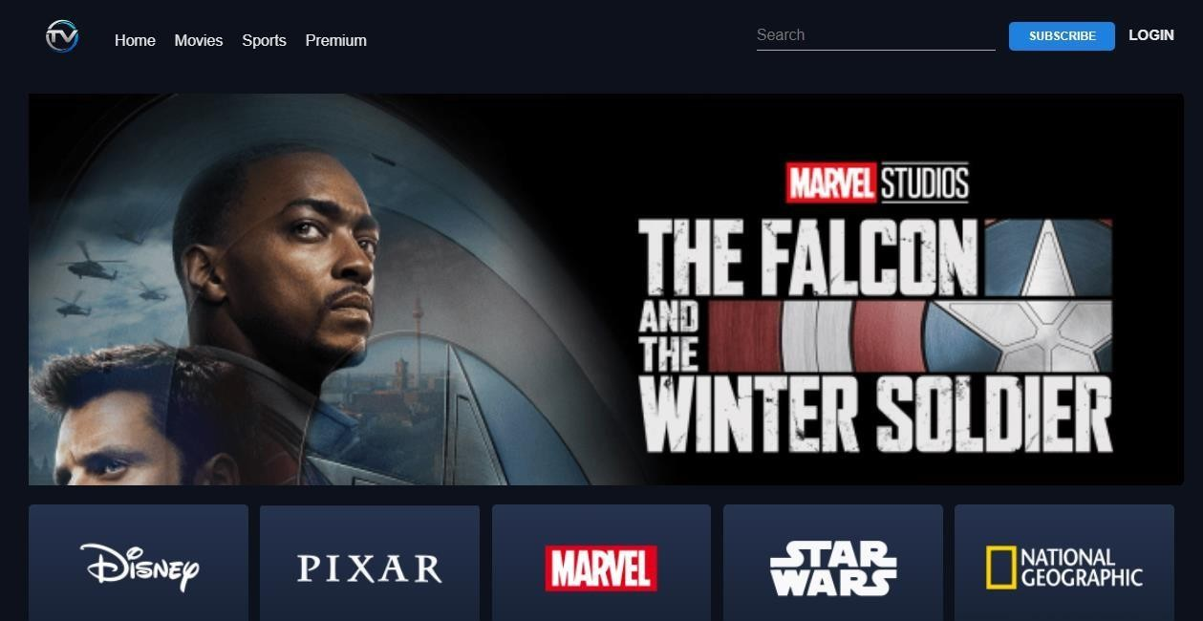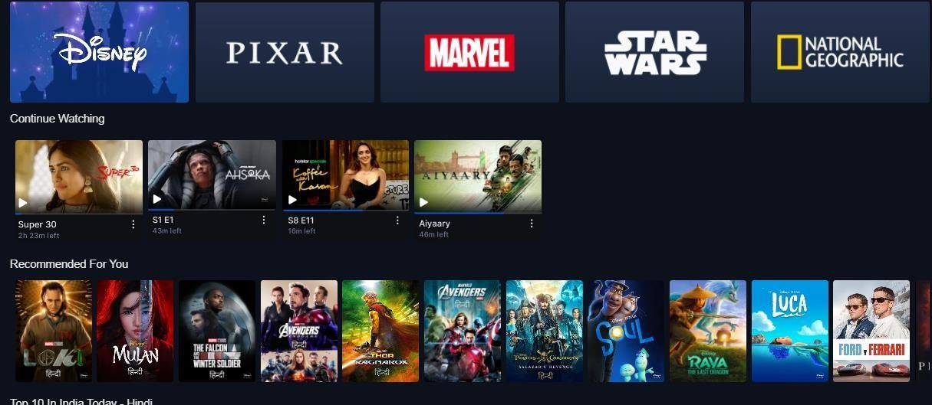Fig 2.2

Fig 2.3

On Day 3, I focused on developing the sports page (sports.html). This day was dedicated to creating a comprehensive and engaging section for sports enthusiasts. The layout included several key sections to provide users with a rich experience:

* **News Updates**: A section dedicated to the latest sports news, including headlines and brief descriptions. This section used HTML elements like articles and divs to keep the content well-organized and easy to read.
* **Upcoming Events**: This section featured a list of upcoming sports events as shown in fig 3.2. Using lists and divs, I created a chronological layout that helps users quickly see what's next on the sports calendar.

To ensure a clean and appealing look, I employed CSS to style these sections. This included:

* **Color Scheme:** A sporty and vibrant palette that aligns with the website's overall theme.
* **Typography:** Clear and readable fonts for headlines, scores, and event details.

JavaScript was utilized to add interactivity to the page. Even without live scores and real- time data, the JavaScript functionalities included:

* **Automatic Sliders:** I implemented automatic sliders to cycle through featured news articles as shown in fig 3.1. This added a dynamic element to the page, making it more engaging and visually appealing. The sliders automatically transition between items, ensuring users are constantly presented with fresh content.

By the end of Day 3, the sports page was transformed into a well-organized, visually appealing, and interactive section of the website. The automatic sliders, in particular, added significant value by continuously displaying key content, making the website a one-stop destination for sports fans, even without real-time data integration.

#### Automatic scrollable slider

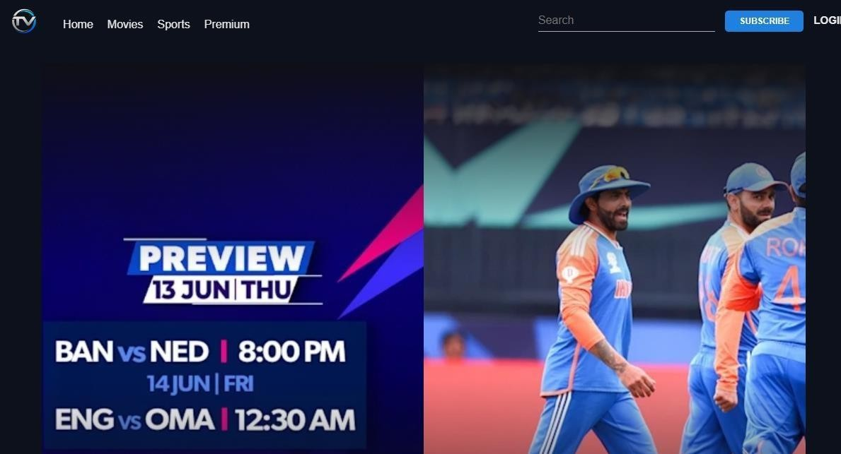

Fig 3.1

#### Sports upcoming events

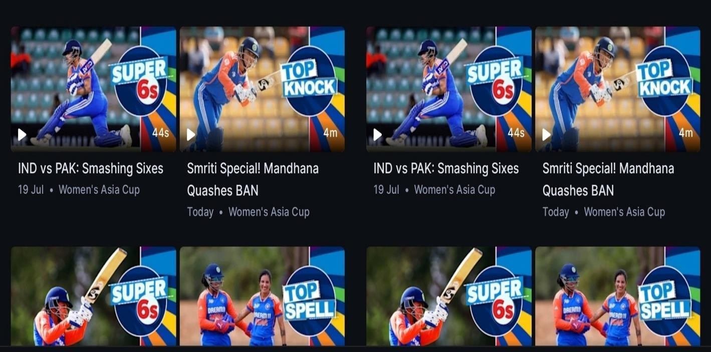

Fig 3.2

On Day 4, I focused on the development of the movies page (movies.html). This day was dedicated to creating a captivating and informative section for movie enthusiasts. The layout included several key sections to provide users with a rich and engaging experience:

* **Featured Movies:** A section dedicated to highlighting popular and must-watch movies. This section used large images and brief descriptions to draw users' attention.
* **Latest Releases:** A section that showcases the most recent movies released. This was organized in a grid layout to efficiently display multiple movies as shown in fig 4.2.
* **Movie Reviews:** A section where users can read reviews of various movies. This was structured using articles and divs to keep the content well-organized and easy to navigate.

To ensure a visually appealing presentation, I applied CSS to style these sections. This included:

* **Color Scheme:** A cinematic palette that aligns with the entertainment theme.
* **Typography:** Clear and stylish fonts for movie titles, descriptions, and reviews.

JavaScript was utilized to enhance the interactivity of the page. The functionalities included:

* **Automatic slider:** An autometic sliders were incorporated to display trending movies, new releases, and other featured sections as shown in fig 4.1. These sliders make it easy for users to browse through a large amount of content quickly.
* **Dynamic Content**: JavaScript was used to dynamically insert content into the HTML, making the user experience more interactive.

##### Movies page automatic slider

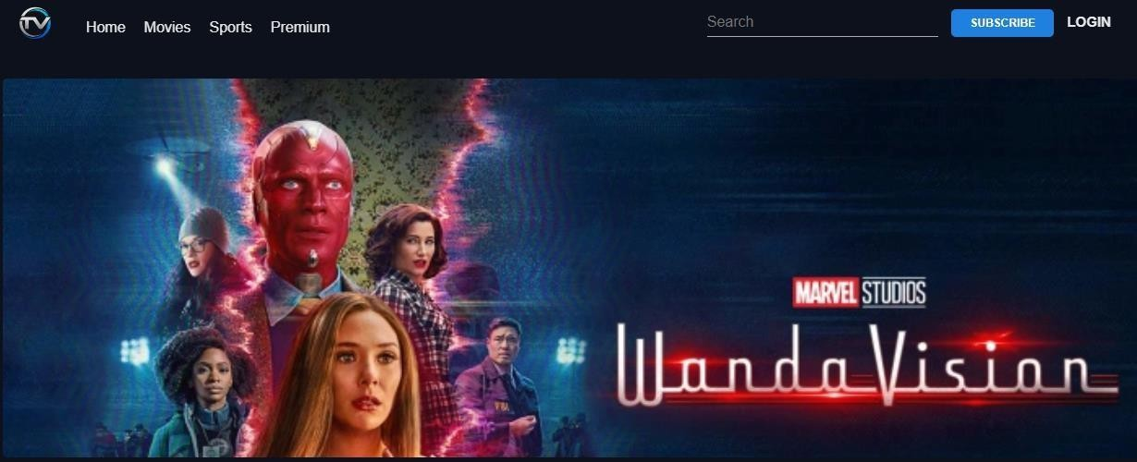

Fig 4.1

##### Scrollable movies list

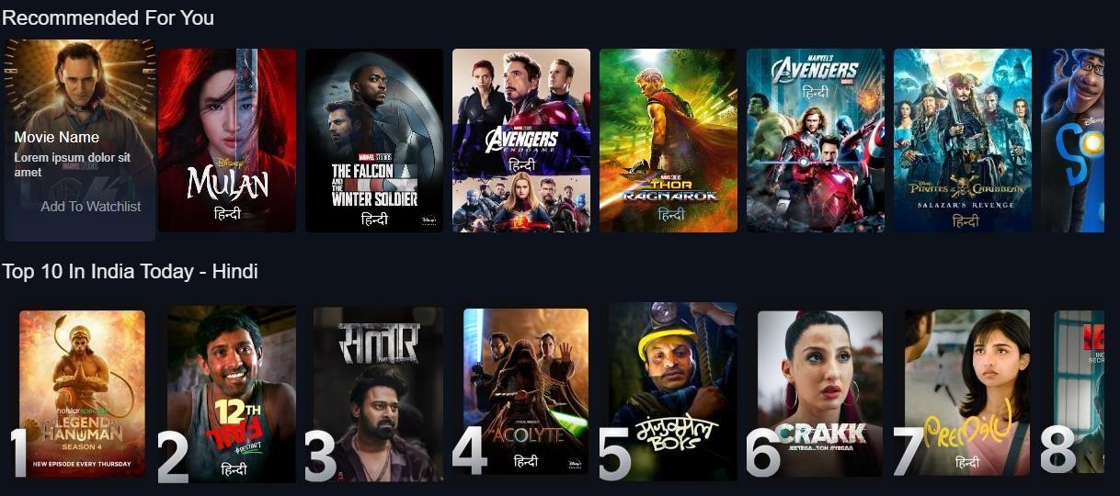

Fig 4.2

On Day 5, I concentrated on developing the premium page (premium.html), designed specifically to showcase exclusive content available to users who subscribe to the premium service. This page is a vital component of the website, as it enhances user engagement by providing added value to those who opt for a premium experience.

To begin with, I crafted a structured layout that emphasizes premium content. The layout featured several sections, including:

* **Exclusive Content Showcase:** A visually appealing area highlighting premium movies, shows, or articles that are accessible only to subscribers. This section used eye-catching images and succinct descriptions to entice users as shown in fig 5.1
* **User Recommendations and FAQ:** A personalized section that suggests content based on user preferences and viewing history. This was designed to engage users by offering them tailored recommendations that align with their interests as shown in fig 5.2

To differentiate the premium content from regular offerings, I applied CSS styling that included:

* **Distinct Color Scheme:** A unique color palette that signifies exclusivity, helping premium content stand out.
* **Highlighting Features:** Use of borders, shadows, and unique font styles to create a sense of luxury and appeal.

JavaScript was instrumental in enhancing the functionality of the premium page. I implemented several key features, including:

* **User Authentication:** A secure login system that validates user credentials, ensuring that only subscribed users can access premium content. This feature was implemented with user-friendly prompts and feedback for a seamless experience.

.

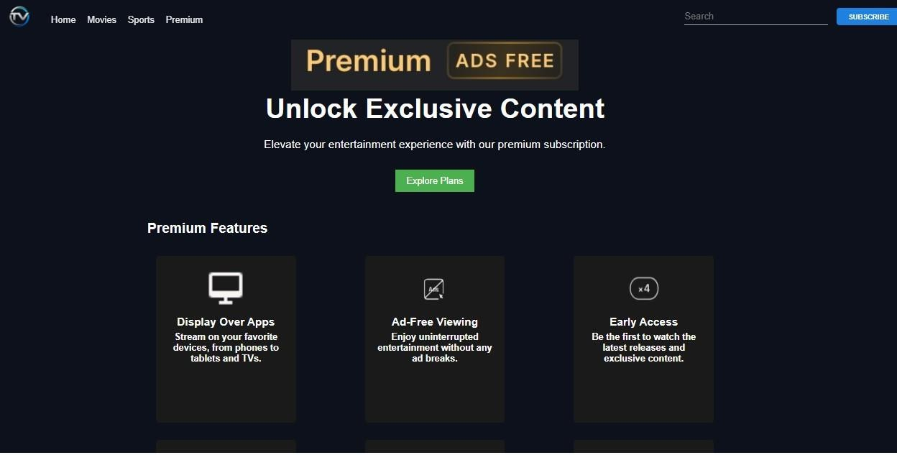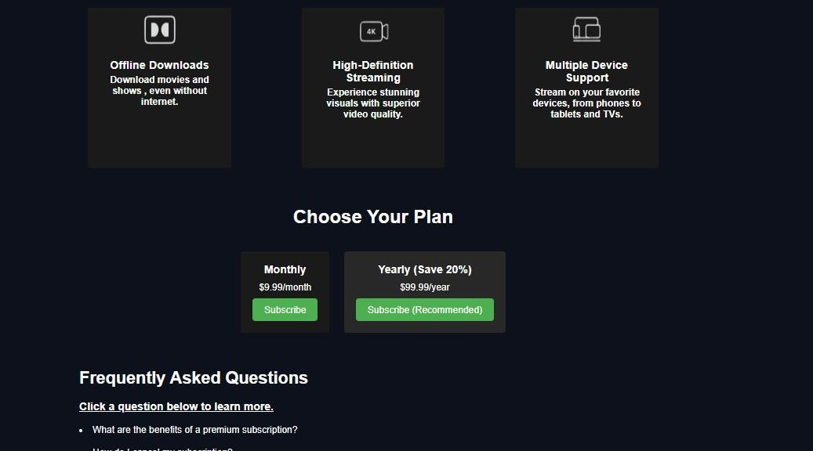

#### Showing exclusive premium features

Fig 5.1

#### Showing your plan and frequently asked question

Fig 5.2

On Day 6, I concentrated on developing the login page (login.html), which serves as a critical entry point for users to access their accounts and utilize the features of the "Entertainment Frontend Website." Creating an intuitive and secure login interface was a priority to ensure a smooth user experience.

To begin, I designed a user-friendly layout that included:

* **Login Form:** A straightforward form where users could input their credentials, including fields for the username and password as shown in fig 6.1.
* **Call-to-Action Buttons:** Clear and accessible buttons for logging in, as well as options for users to navigate to registration or password recovery if they encountered issues.

Using CSS, I focused on styling the form elements to create a cohesive and visually appealing look. This included:

* + **Consistent Design:** Ensuring that the login form matched the overall aesthetic of the website, utilizing the same color scheme and font styles.
  + **Responsive Design:** Applying media queries to ensure the login form looked great on various devices, providing a consistent experience whether on desktop or mobile.

I implemented JavaScript to enhance the functionality of the login page by adding:

* + **Form Validation:** Client-side validation to check that the fields were filled out correctly before submission. This included checking for empty fields and ensuring that the entered email format was valid.
  + **Authentication Logic**: A system for validating user credentials against stored data, ensuring that only authorized users could gain access to their accounts. This feature provided feedback to users, letting them know if their login was successful or if there were any errors.

By the end of Day 6, the login page was effectively designed and implemented, providing users with a secure and seamless experience when accessing their accounts. The combination of CSS styling and JavaScript functionalities not only enhanced the overall user experience but also instilled confidence in users regarding the security of their personal information while navigating the website.

**Appendix:**

##### Login page accepting user id and password

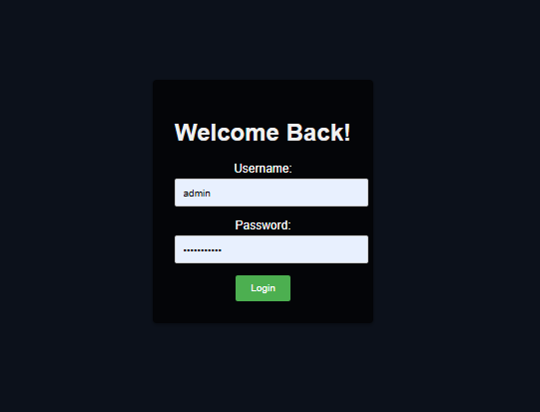

Fig 6.1

.

## Conclusion

The development of the "Entertainment Frontend Website" has been a successful endeavor, achieving its primary goal of creating a visually appealing and functional platform for entertainment. Throughout the project, we employed HTML for structuring the content, CSS for designing the layout, and JavaScript to enhance interactivity and user experience.

The website effectively integrates various entertainment aspects, including sports, movies, and premium content, into a cohesive and user-friendly interface. Each page was meticulously designed to provide users with an engaging and intuitive experience. The homepage offers a comprehensive view of featured content, while the sports and movies pages cater to specific interests with organized sections for relevant updates and information.

The premium page highlights exclusive content for users, showcasing the ability to offer tailored experiences without relying on external APIs. This demonstrates the project's capability to deliver a robust entertainment platform while maintaining simplicity and control over the content.

Overall, the project meets our expectations for a frontend entertainment website. It stands as a testament to the effective application of web technologies and highlights the importance of creating user-centric designs. Future improvements could include incorporating dynamic content updates and expanding features to further enhance the user experience.